Lab 09

- ) Leagues
league_name -> * none *

Teams
team_name -> the set and all subsets of {league_name,age_group}

People
Pid -> the set and all subsets of {fname,lname,address,phonenumber}

Team Players
pid -> team_name

Coaches
pid -> years_coached

Team Coaches
tcid -> the set and all subsets of {age_group,team_name}
tcid -> {pid,age_group}
tcid -> {pid,team_name }
(pid,age_group) -> tcid
(pid,team_name) -> tcid

Assistant_Coaches
tcid -> * none *

Head Coaches
(tcid,team_name) -> none

2.)
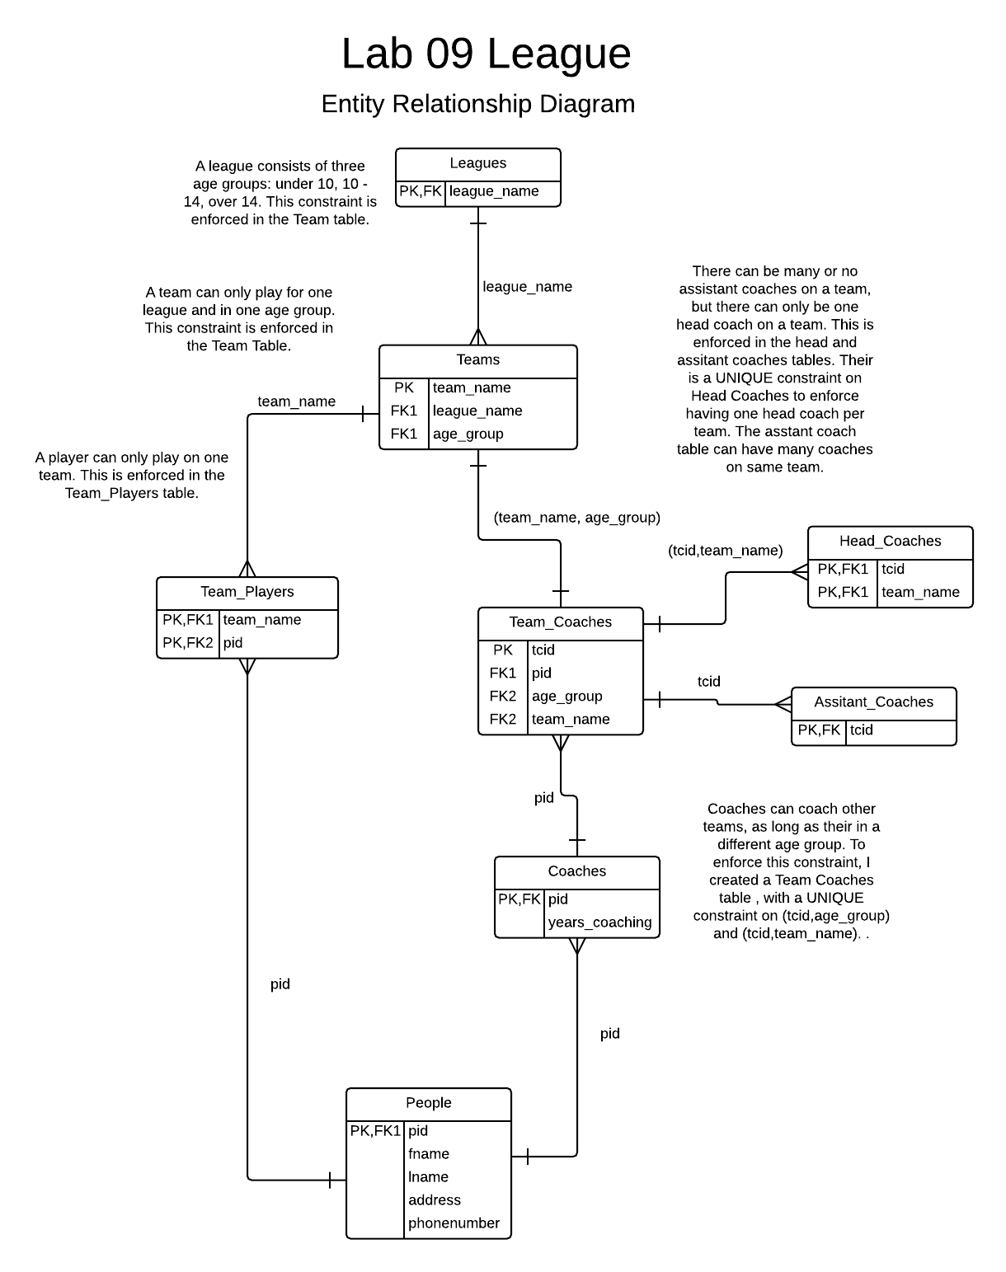

\

3.) To prove my database is in NF3, first I must prove its in NF1. Its in NF1 as all data is atomic. Next I prove its in NF2. Its in NF2 as its in NF1, and using the dependencies I see there are no non-primary attributes dependent on just one part of a subset of a candidate key. Finally I prove its in NF3. Its in NF3 as its in NF2, and their are no transient dependencies in the form A-> B and B-> C so A -> C where A != C. There are transient dependecies on the Team_Coaches table, but a UNIQUE(pid,team_name) and UNIQUE(pid,age_group) enforce BCNF.

